Viking Cash Crusade
NWGMS PTSO

The NWGMS PTSO is proud to host the seventh annual Viking Cash Crusade. The Viking Cash Crusade in the main fundraiser for the NWGMS PTSO and is a direct donation campaign.

Our fundraiser will not only aid our PTSO’s mission of supporting our staff and students, but also in our quest to support Northwest Middle teachers with the resources needed to increase student engagement and literacy outcomes. The goal is to provide the resources for all content areas and grade levels, so this fundraiser will touch the lives of each and every student in our school. Now more than ever, we need you. We are hoping to raise a minimum of $20,000 from the Viking Cash Crusade Campaign and hope that you will help us achieve our goal.

To say thank you to our families for participating in the Viking Cash Crusade AND to make it fun for students, we are featuring some amazing raffle prizes. Students will receive raffle tickets based on the value of the monetary donation. Again this year, we will be filling out the students’ tickets and getting them into the appropriate buckets. Students will designate which prizes they would like the chance to win. Prizes will be raffled at the end of the fundraiser with the drawing taking place on Friday, October 7th.

We are hoping for 100% family participation in our Viking Cash Crusade Campaign. The recommended amount is $100 per family, but all donations, larger or smaller, are greatly appreciated and are tax deductible. Please keep a copy of your check or online receipt for your tax purposes.

Please email us at ptsonwgms@gmail.com with any questions or concerns.

We would like to recognize and thank this year’s sponsor, Maureena Shepherd and Associates.

Viking Cash Crusade
NWGMS PTSO

DONATE MONEY. WIN PRIZES.
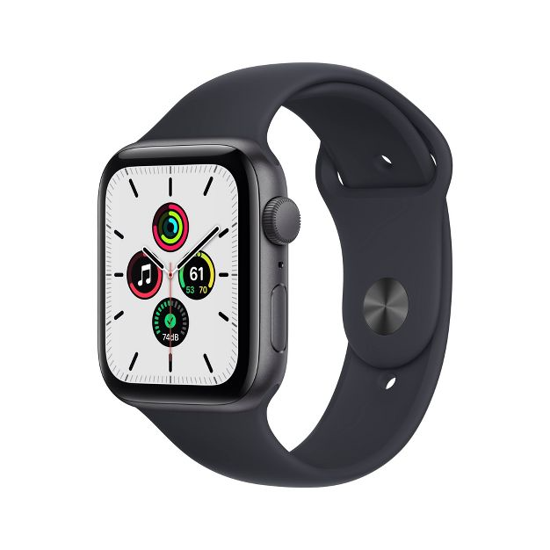
Apple Watch SE 40mm
Value: $280

Breakout Escape Room
Escape for a group of up to 8
Value: $200
50” Vizio Smart TV
Value: $380

Students will receive 1 raffle ticket for every $10 donated.

Use the following QR code to be taken directly to our PTSO site to donate online.

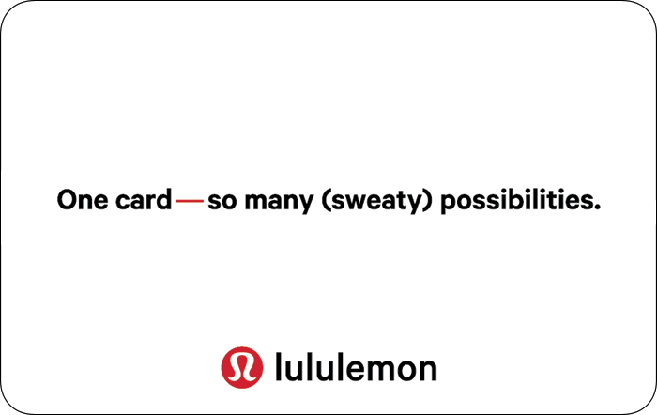

Lululemon Gift Card
Value: $250
Apple Air pod Pros
Value: $250

Student Name: _____________________________________________________
Parent/Guardian Name: ______________________________________________
Parent/Guardian Email/Phone: _______________________________________________________________
Student AA Teacher: _________________________________________ Grade: _____________
Donation Amount: $_______________ Cash____ Check____ Online____

Students will receive 1 ticket for each $10 donated. Please indicate how your student would like their tickets entered. Please complete a separate form for each student in your family and attach if you combine payments. If you would like us to split tickets between your students, please make a not below.

**For example, if you donate $100, you will receive 10 tickets. You may choose to enter 3 for the watch, 2 for the TV, 2 for the Breakout games and 3 for the Air pods.

_______ Apple Watch _______ 50” Smart TV _______ Lululemon Gift Card

_______ Breakout Games _______ Air pod Pros

Donations can be made online, NWMSPTSO.ORG or by mail:
NWGMS PTSO, 5240 NW SCHOOL RD, GREENSBORO, NC 27409

