HBI 4-a-Side Rules

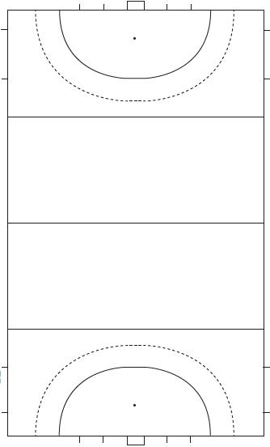

Field of Play

16 yard line

Half way

D

End Line
25

Game Time

2 x 20 minute halves or as directed by the committee

Ball Outside the Field

A ball is out of play when it passes completely over the side-line or back-line.

In the event that the ball crosses the end line play will be restarted by the defending team from the 16 yard line in line with the point at which the ball crossed the end-line

In the event that the defending team deliberately hit the ball over the end line play will be restarted by the attacking team from the 25 in line with the point at which the ball crossed the end-line

If the ball crosses the sideline within the 16 the defending team will start play on the 16 yard line. The attacking team will start play on the 25.

Conduct of Play

The head of the stick should be kept low; below the hips of surrounding players at all times.

The ball can be moved by dribbling, pushing, sweep hits and jinks. Jinks must be kept below the knees of surrounding players.

Upright hits are not permitted.

Only one player from each team may be involved in playing the ball at any time.

Penalties

Short Corners

There are no short corners. The ball is instead taken by the attacking team from the 25 in line with where the penalty occurred.

Repeat Offences in the D

The defending player responsible will be sent to the opposite end of the field until the ball leaves the 25

Free Hits

Free hits awarded to the attacking team within the 16 can be taken from the spot or from the 25 in line with where the offence occurred.

