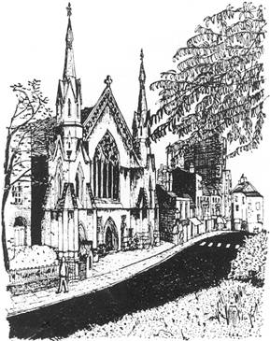

**HEATH STREET BAPTIST CHURCH HAMPSTEAD**

**84 Heath Street, London, NW3 1DN**

**Treasurer Minister**

Mrs Gaynor Humphreys Ewan King

2 Wentworth Mansions 63 Agincourt Road

Keats Grove London

London NW3 2PA

NW3 2RL

gaynor@eandghumphreys.plus.com ewan_king@mac.com

Tel. 020 7435 0636

Charity registration number 1178001

CHARITY GIFT AID DECLARATION

multiple donation

|  |
| --- |
| **Boost your donation by 25 pence of Gift Aid for every £1 you donate**  Gift Aid is reclaimed by the charity from the tax you pay for the current tax year.  Your address is needed to identify you as a current UK taxpayer. |

**In order to Gift Aid your donation you must tick the box below:**

**•** I want to Gift Aid any donations I make in the future or have made in the past four years to:

**Name of charity: Heath Street Baptist Church**

I am a UK taxpayer and understand that if I pay less Income Tax and/or Capital Gains Tax than the amount of Gift Aid claimed on all my donations in that tax year it is my responsibility to pay any difference.

**My details**

Title First name or initial(s)

Surname

Full home address

Postcode

Date -----------------------------------------------------------------------------------------------

Signature ------------------------------------------------------------------------------------------

Please notify the charity if you:

* Want to cancel this declaration
* Change your name or home address
* No longer pay sufficient tax on your income and/or capital gains.

If you pay Income Tax at the higher or additional rate and want to receive the additional tax relief due to you, you must include all your Gift Aid donations on your Self Assessment tax return or ask HM Revenue and Customs to adjust your tax code.