The below is an email received by one of our members. As you can see this contains several errors. Clearly this is a scam and the Orange link at the bottom should Never be clicked on under any circumstances.

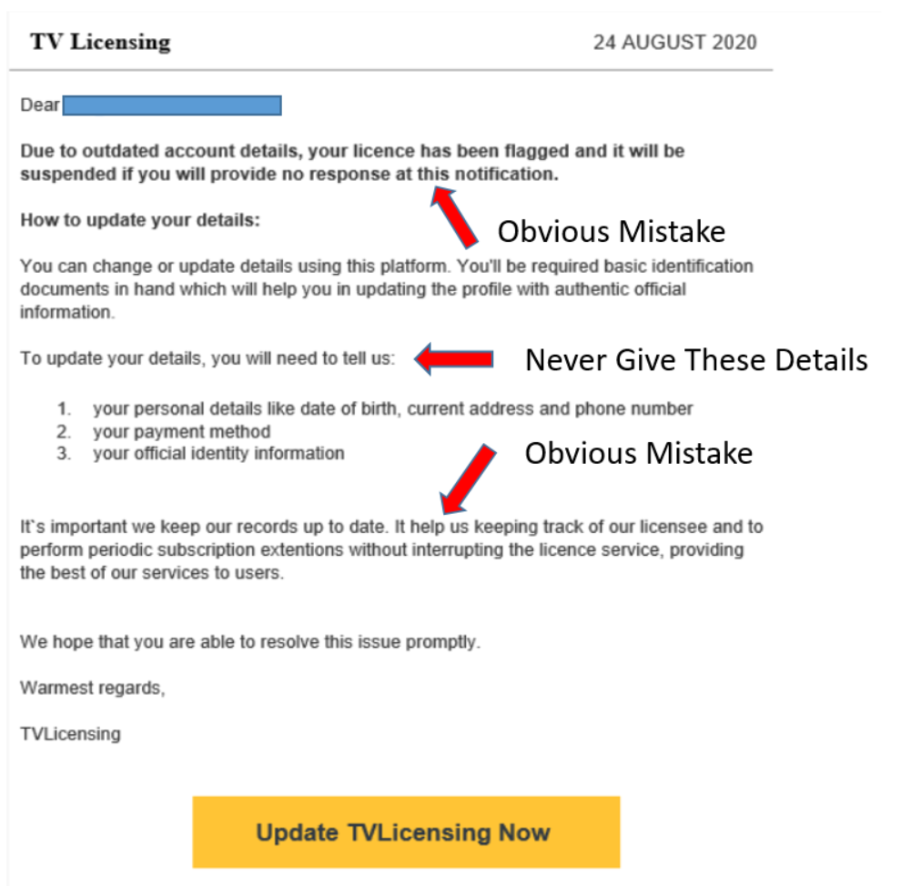

The below information has been sourced from the Age UK website and provides useful information on general TV Licence Scams and what to look out for. (Apologies for the small print)

